GUIDELINES FOR PREPARATION OF SYNOPSIS REPORT
SYNOPSIS OF
<Title of the work – TNR – 16 font size - Bold>
A THESIS
to be submitted by
<Name of the student – TNR – 12 font size -Bold >
for the award of the degree of
Doctor of Philosophy

<Name of the School – TNR – 12 Font size – All caps – Bold>
<Name of the Department – TNR – 12 Font size – All caps – Bold>
VIGNAN'S FOUNDATION FOR SCIENCE, TECHNOLOGY & RESEARCH
(Deemed to be University), VADLAMUDI
GUNTUR – 522 213, ANDHRA PRADESH, INDIA
<Month, Year>

1. INTRODUCTION
<sample text is given here. Use Times new Roman Font with 12 size>.
In general, any component failure starts at the surface due to either an isolated manufacturing discontinuity or gradual deterioration of the surface quality. One of the important parameters contributing to the surface integrity of components is the surface roughness. Surface roughness is an important indicator of product quality in addition to dimension and form. In manufacturing, surface finish must be maintained very much within the designer's specifications as it has direct influence on many of the fundamental requirements such as the load bearing strength of the assemblies, fatigue strength, coating/plating of surfaces etc. Surface roughness is a vital indication of the quality of machined work pieces and the manufacturing process as well (Al-Kindi et al, 1992).
But there are certain disadvantages of this contact mechanical stylus instrument which include the possibility of surface/stylus damage due to wrong handling and longer inspection time etc. (Kiran et al, 1998, Gupta et al, 2001).
A computer is then used to process and analyze the images based on the intended application, often by trying to recognize a pattern or by making a measurement.

2. MOTIVATION
<sample text is given here. Use Times new Roman Font with 12 size>.
Over the years, the non-contact optical methods have attracted researchers' attention for the assessment of surface roughness. Most of the methods are based on statistical analysis of grey-level images in the spatial domain.

3. OBJECTIVES AND SCOPE OF THE PRESENT WORK
The objectives of the present work are
- <Objectives are mentioned here. Use TNR Font with 12 size, all objectives numbered>.
- Estimation of optical surface roughness parameters of inclined components using images.
- Prediction of surface roughness of inclined component using ANN, ANFIS and GMDH.
- Use of shadow detection and removal algorithm on images of inclined components.
- Analysis of effect of shadow on smooth and rough surfaces with particular reference to inclined components.

4. DESCRIPTION OF THE RESEARCH WORK

4.1 <Sub heading – TNR – 12 font size – capitalize each word - bold>
<sample text is given here. Use Times new Roman Font with 12 size>.
A rough surface in general is expected to have more shadows in the image. It causes the light to scatter in all directions. While a perfectly smooth surface is likely to have more brightness and less shadow, reflect light more uniformly in the same direction confining to a small narrow region. Shadows occur either at places where the path from the light source is blocked or on the surfaces which are oriented away from the light source.

4.1.1 <Sub-sub heading – TNR – 12 font size – sentence case - bold>
<sample text is given here. Use Times new Roman Font with 12 size>.
The schematic diagram of the machine vision system is shown in fig. 2. The basic experimental set-up consists of a vision system (CCD camera: Pulnix -TM6, 768 x 565 pixels) and an appropriate lighting arrangement. Illumination of the specimens was accomplished using a diffused white light source, which is kept at an angle of approximately 45° incidence with respect to the specimen surface as shown in fig. 2.

4.1.2 <Sub-sub heading – TNR – 12 font size – sentence case - bold>
<sample text is given here. Use Times new Roman Font with 12 size>.
The most important requirement in roughness assessment using machine vision is to extract the roughness parameters of surfaces using images. In this work, surface roughness parameters are extracted based on statistical parameters using histogram, spatial frequency domain, grey level co-occurrence matrix etc.

4.1.2.1 <Sub-sub-sub heading – TNR – 12 font size – sentence case - bold>
<sample text is given here. Use Times new Roman Font with 12 size>.
The intensity distribution of the pixels (grey level histogram) of images is plotted. Based on the statistical parameters associated with each histogram, calculations were made to determine the roughness parameters were estimated.
Optical Roughness Parameter, R
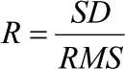
Where SD is standard deviation of the distribution, RMS is root mean square height of the distribution.
Average grey level coefficient, α
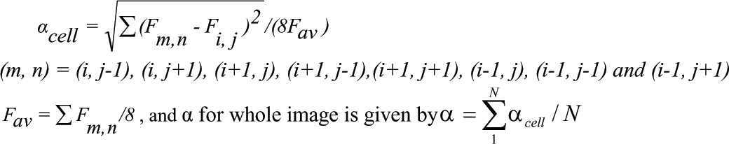

4.1.3 <Sub-sub heading – TNR – 12 font size – sentence case - bold>
<sample text is given here. Use Times new Roman Font with 12 size>.
With nine test samples and twelve varying angles of inclinations as indicated, 117 combinations are possible and all of them have been used for estimation. Roughness parameters are then calculated for all the 9 test specimens at different angles of inclination (0°-12°). The input and output data are separated into training and testing sets. Out of 117 images 94 are used for training and remaining 23 are used for testing. The selection of testing and training data is based on the work done and the results obtained by earlier researchers.

4.2 <Sub heading – TNR – 12 font size – capitalize each word - bold>
<sample text is given here. Use Times new Roman Font with 12 size>.
Traditional pre-processing algorithms do not specifically consider shadows present in an image. But this is particularly crucial for the roughness estimation of the specimens as they are likely to have an inclination with the horizontal during imaging. Therefore, it is essential to possibly remove shadows present, if any, due to such inadvertent inclinations or due to high/ low illumination. Several algorithms for shadow detection and removal exist in the literature (Finlayson et al, 2002 and Levin et al, 2005). While removing the shadow from an image, it is important to consider the application for which the pre-processing is carried out. In this case, the requirement is to extract meaningful information from an image representing the surface texture. It is necessary to obtain the resulting image, which is shadow free and contains the details present in the original image without any loss of information.

5. CONCLUSIONS
<sample text is given here. Use Times new Roman Font with 12 size>.
In general, it has been observed that imaging of surfaces to evaluate the surface finish of components have problems such as illumination, inclination of the components etc.
Therefore, it is understood that the proposed methodology in this work can be applied for evaluation of surface roughness using machine vision approach in a much-improved fashion.

REFERENCES
<All references should be alphabetically arranged. A few examples of formats of references are given below and the student should be consistent in following the style>
Journals
Exner, H.E. (1979). Physical and Chemical Nature of Cemented Carbides, International Metals Review, 24, 149-173.
Spriggs, G. E. (1970). The Importance of Atmosphere Control in Hard Metal Production, Powder Metallurgy, 13 (26), 369-393.
Conference Proceedings
Fischmeister, H. F. (1982). Development and Present Status of the Science and Technology of Hard Materials, Science of Hard Materials, R.K. Viswanadham, D.J. Rowcliffe, and J. Gurland (eds.), Plenum Press, New York, NY, USA, 1-45.
Baek, W. H, Hong, M. H, Lee, S and Chung, D T. (1995). A Study on the Shear Localization Behavior of Tungsten Heavy Alloy, Tungsten and Refractory Metals, A. Bose and R.J. Dowding (eds.), Metal Powder Industries Federation, Princeton, NJ, USA, 463-471.
Books
German R. M. (1994). Powder Injection Molding, Metal Powder Industries Federation, Princeton, NJ, USA, 1990.
Thesis
Johnson, J. L. (1994). Densification, Microstructural Evolution, and Thermal Properties of Liquid Phase Sintered Composites, Ph.D. Thesis, The Pennsylvania State University, University Park, PA, USA.
Technical Reports
Zukas, E.G, Rogers, P. S. Z and Rogers, R. G. (1992). Experimental Evidence for Spheroid Growth Mechanisms in the Liquid Phase Sintered Tungsten Based Composites.
Patents
Oenning, V and Clark, I. S. R. (1991). Tungsten skeleton structure fabrication method, U. S. Patent No. 4988386.
Journals in Non-English Language
Weihong, L and Xiuren, T. (1988). Tungsten Matrix in Cu-W Contact Materials by Impregnation Process, Powder Metallurgy Technology, 6 (8), 1-4. (in Chinese)

PROPOSED CONTENTS OF THE THESIS
<The chapter headings with sub/sub-sub headings to be mentioned here. A sample is provided>
CHAPTER 1 Introduction
1.1 General
1.2 Surface roughness evaluation
1.3 Machine vision approach
1.4 Objectives and scope of the present work
1.5 Organization of the thesis
CHAPTER 2 Literature review
2.1 Introduction
2.2 Brief literature review
2.3 Problem identified from literature review
CHAPTER 3 Surface roughness evaluation of inclined components
3.1 Introduction
3.2 Experimental procedure
3.3 Estimation of surface roughness parameters
3.4 GMDH
3.5 ANN
3.7 Conclusions
CHAPTER 4 Roughness estimation using improved quality images
4.1 Introduction
4.2 Illustration of formation of shadow
4.3 Shadow detection and removal
4.4 Influence of shadow on smooth and rough surface
4.5 Results and discussion
4.6 Conclusions
CHAPTER 5 Analysis of components inclined on both sides
5.1 Introduction
5.2 Experimental Procedure
5.3 Estimation of Surface Roughness Parameters
5.4 Edge enhancement
5.5 Result and discussion
5.6 Summary and conclusions
CHAPTER 6 Conclusions and scope for future work

REFERENCES / BIBLIOGRAPHY

PUBLICATIONS BASED ON THIS RESEARCH WORK
Refereed International Journal:
<Publications came out of the thesis (only the published and accepted papers) to be mentioned here. Example is shown below>
- Nevin, A. (1990). The changing of teacher education special education. Teacher Education and Special Education: The Journal of the Teacher Education Division of the Council for Exceptional Children, 13(3-4), 147-148.
International Conference:
- Priya, P and Ramamoorthy, B. (2006). Surface Roughness Analysis of Inclined Components Using Machine Vision, International Conference on Global Manufacturing and Innovation (GMI-2006), CIT Coimbatore, INDIA.
- Priya, P and Ramamoorthy, B. (2006), Roughness Estimation of Inclined Surfaces Using Artificial Intelligence, 18th IMEKO World Congress, Metrology for Sustainable Development, Rio de Jeneiro, Brazil.
- Priya, P and Ramamoorthy, B. (2006), Surface Roughness Assessment of Inclined Components Using Machine Vision and Adaptive Neuro Fuzzy Inference System, 22nd AIMTDR Conference, IIT Roorkee, INDIA, pp 163-168.
<All figures and tables to be kept after the text. Figures to be named below and tables above.>
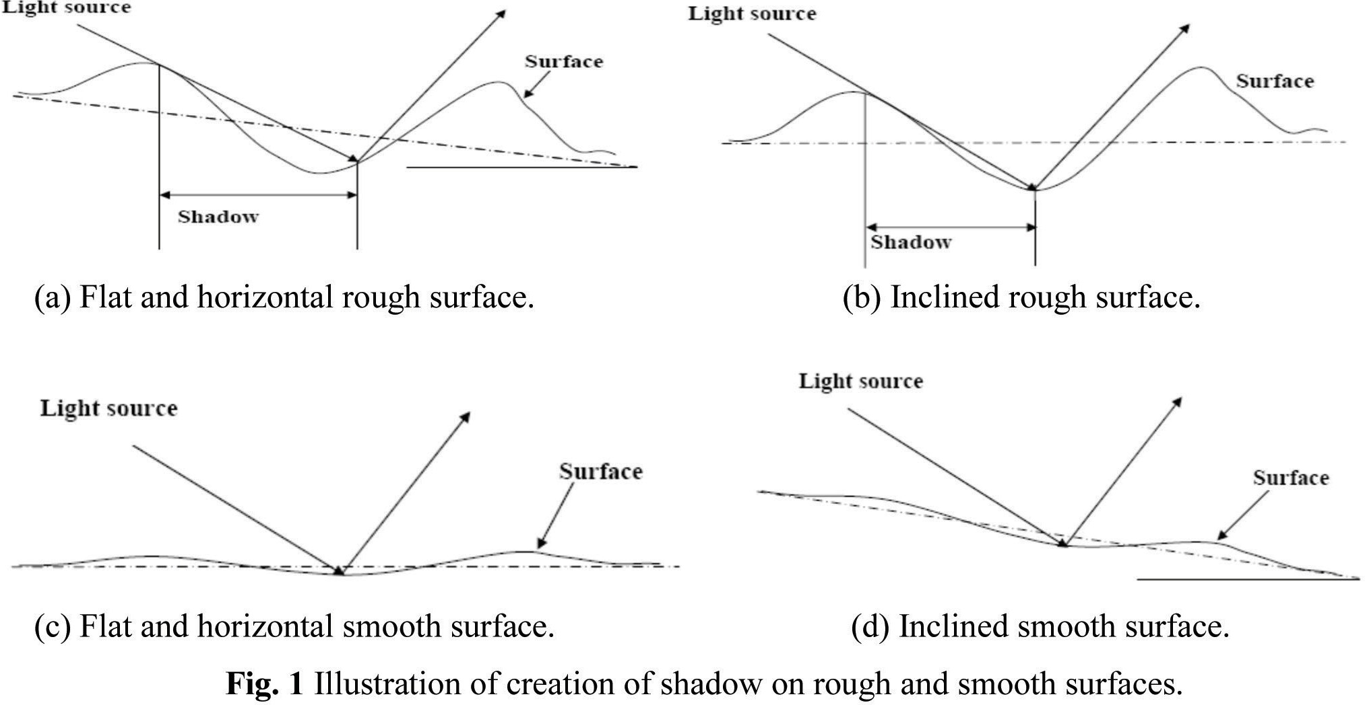
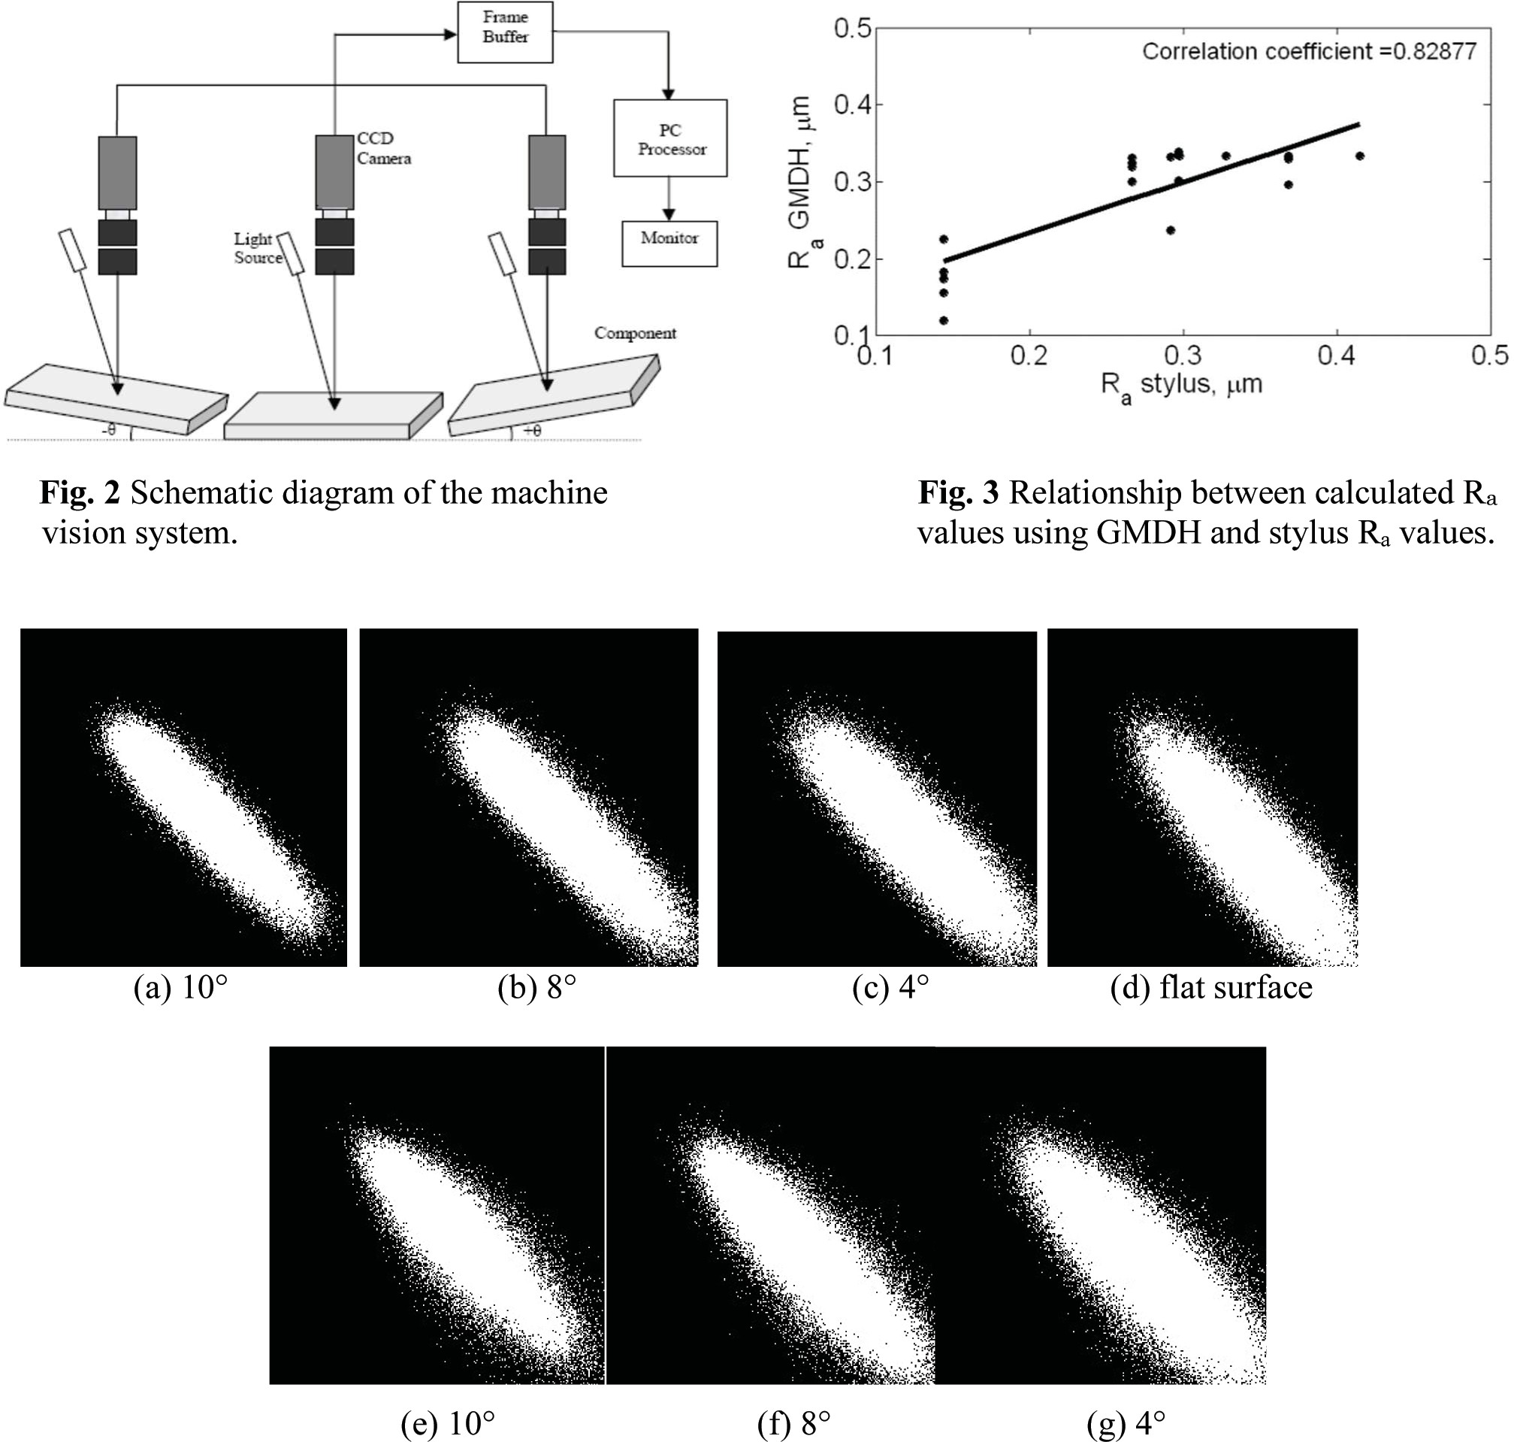
Fig. 4 2D plots of GLCM (a), (b), (c), (d) before shadow removal and (e), (f), (g) after shadow removal at varying inclination

GENERAL INSTRUCTIONS:
- Letters type - Times Roman, Font size 12, single spacing
- Number of pages 14 to maximum of 20.
- The first page to be precisely followed as shown.
- Literature survey – must contain points related to the thesis and suitably added with comments.
- Reference of the literature has to shown in the text as given – to be followed as a standard.
- References in the end are to be given in the alphabetical order. All the references MUST be referred in the text.
- All the Equations, figures, graphs, charts and tables are to be numbered, Fig 1, Fig 2… Table 1, Table 2, … and referred in the text.
- All the figures, graphs, charts and tables titles must be self-explanatory, Figure titles should appear at the bottom and the Table titles at the top.
- At the time of Synopsis meeting, rough draft of the thesis must be presented to the committee. The thesis MUST be submitted within one month from the date of approval of the synopsis.
- It is suggested that the Tables, figures etc are to be given in the end to adjust and minimize the space and number of pages.
- Guide MUST present the list of examiners (5 Indian and 5 foreign examiners) to the committee for approval.

